MLA 8 Format Cheat Sheet

This handout provides a quick reference to the basics of using MLA style. For complete guidelines, consult the MLA Style guide website: https://style.mla.org/

Formatting Basics
- Plain 12-point font (Arial, Times New Roman)
- Double space throughout paper, with no extra spaces between paragraphs.
- Top, bottom, and side margins should be one inch.
- Indent the first word of each paragraph by ½ inch or 5 spaces.
- Do not use a title page for the research paper: instead simply type your name, instructor’s name, course number, and date. This should be flush with the left margin.
- Center the title of the paper. Do not underline the title, or put in “quotation marks,” or set in ALL CAPITALS.
- Number all pages consecutively in a header in the upper right corner, ½ inch from the top and flush with right margin. Type your last name before the page number, and do not use “p.” before the number.

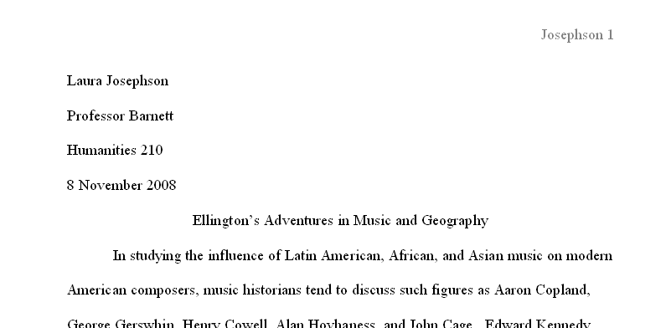

SAMPLE FIRST PAGE:

Works Cited

MLA style requires that the list of Works Cited start on a new page at the end of your paper. Formatting rules include:
- Continue page numbering from the body of your paper.
- Center the title “Works Cited,” one inch from the top.
- Alphabetize entries by the author’s last name. If no author, alphabetize by the title (ignore A, An,The).
- Use a hanging indent.
- Remember that any source that shows up on your Works Cited page MUST be cited in the text of your paper (in-text citations). These work just like the did in MLA 7. If you have questions, feel free to ask!

In the 8th Edition of MLA, you include the “core elements” of the sources. Core elements are those basic pieces of information that should be common to all sources, from books to articles, from lectures to tweets. The MLA core elements (with the punctuation that should follow each element) are as follows:

1. Author. (Last Name, First Name; Online nicknames and handles are now acceptable if real name isn’t known)

2. Title of source.

3. Title of container.

4. Other contributors, (State specific role, followed by the word “by” and then first and last name)

5. Version, (Abbreviate ed. for Edition and rev. for Revised)

6. Number, (Use vol. for Volume and no. for number, with commas in between)

7. Publisher, (Include only name of publisher, not business words like LLC; use UP for University Press)

8. Publication Date,

9. Location. (Page Numbers (use p. for one page, pp. for page range), URL (Permalink, omit the http://) or DOI. For online journals, DOI is preferred over URL.

A basic citation format should look like. You would omit elements that don’t exist or are unnecessary:

Author. Title. Title of Container. Other contributors, Version, Number, Publisher’s name, Date of Publication, Location.

Examples of Citation Format

Book with one author:

Jacobs, Alan. The Pleasures of Reading in an Age of Distraction. Oxford UP, 2011.

Online database journal article:
Hannah, Daniel K. "The Private Life, the Public Stage: Henry James in Recent Fiction." Journal of Modern Literature, vol.30, no. 3, 2007, pp. 70-94. JSTOR, www.jstor.org.ezproxy.lib.uwf.edu/stable/30053134.

Website:
“Woman Gives Birth to Grandchild.” CNN.com, 15 Oct. 2006, www.cnn.com/2006/WORLD/asiapcf/10/15/japan.granny.reut/index.html.

